# Lab: Generics

This document defines the lab for ["Java Advanced" course @ Software University](https://softuni.bg/modules/59/java-advanced). Please submit your solutions (source code) of all below described problems in [Judge](https://judge.softuni.bg/Contests/1526/Generics-Lab).

## Jar of T

Create a class Jar<> that can store **anything**.

It should have two public methods:

* void add(element)
* element remove()

Adding should add on **top** of its contents. Remove should get the **topmost** element.

### Examples

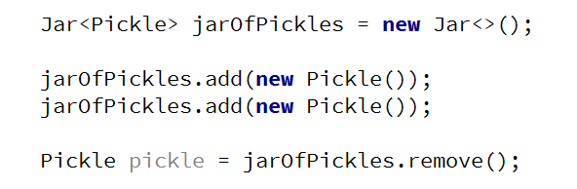

### Hints

Use the syntax Jar<T> to create a generic class.

### Submit in Judge

Submit your solution in Judge **zip** your whole package with the Jar and Main **classes**:

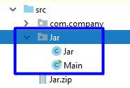

If you didn't create a **package** just choose your classes and **zip** them.

## Generic Array Creator

Create a class ArrayCreator with a method and a single overload to it:

* static T[] create(int length, T item)
* static T[] create(Class<T> class, int length, T item)

The method should return an array with the given length and every element should be set to the given default item.

### Examples

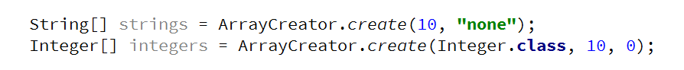

## Generic Scale

Create a class Scale<T> that holds two elements - **left** and **right**. The scale should receive the elements through its single constructor:

* Scale(T left, T right)

The scale should have a single method:

* T getHeavier()

The **greater** of the two elements are heavier. The method should return null if elements are **equal**.

### Examples

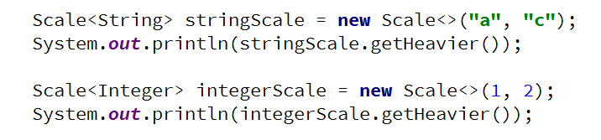

## List Utilities

Create a class ListUtils that you will use through several other exercises:

The class should have two static methods:

* T getMin(List<T> list)
* T getMax(List<T> list)

The methods should throw IllegalArgumentException if an empty list is passed.

### Examples

